1. The Save LPO does not have much of functionality as it will only save the to and from details along with remarks. If saved it will not be used to send email to anyone other than the To & From address that is saved.

Better option will be to have save done with only the read only details n have send LPO as Email button available on click of view LPO details or Intimate Employee button.

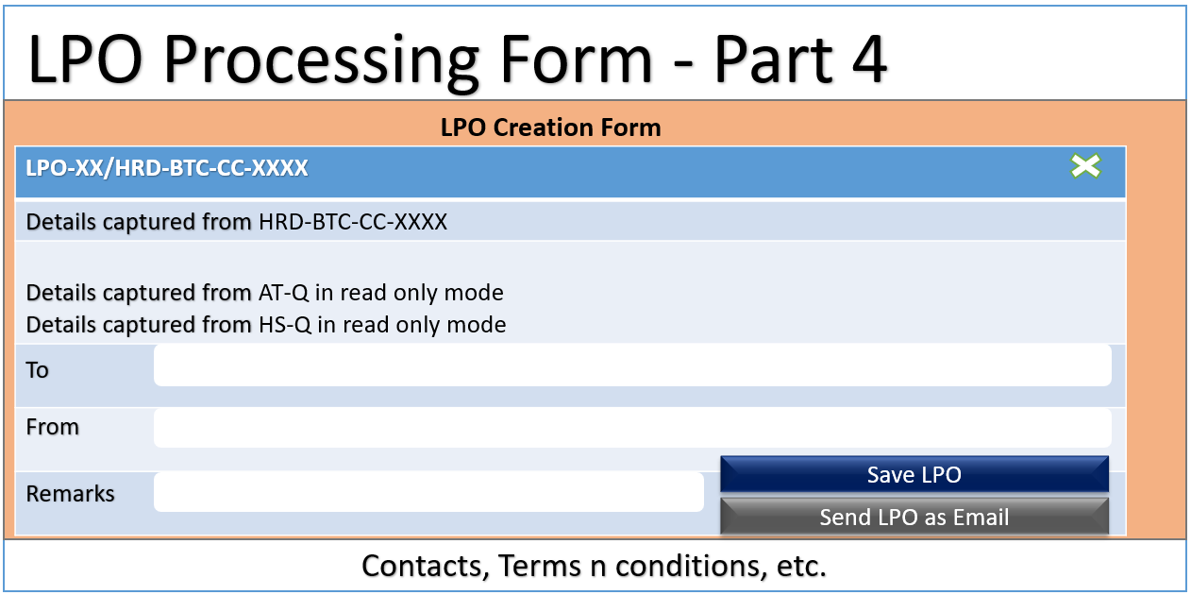

2.The Intimate Employee, is it same as the send LPO as email? If so then we can remove in one of the places.

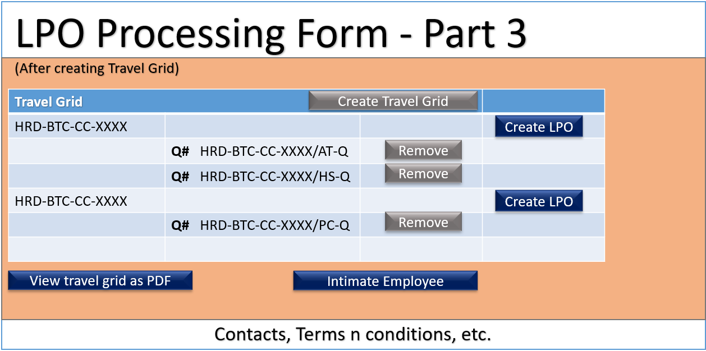

3. Manage Visas form needs details

4. Details for Terms n Conditions, Contacts, or any other information to be displayed on the site.

5. Main page images and details about the BTC website, any logos that is available to be used in the website

6. RFQ and Travel request is having the same number. Is it intentional?

7. Quotation Number does not have a specific format. Considering it will always be visible along with RFQ, I am display it as RFQ : AT-Q/HS-Q/PC-Q

The tables shared earlier has the employee details, but it is not possible to directly relate the employee with their respective managers to get the details. Would require a sample query so that I can use it fetch the details from the existing table. Don’t need any data sample, just the query would suffice.

1. A query to get the employee details from the HRWorks database along with his/her manager details.

2. A query to get the organisational chart like a resultset which has all the employee details, along with their manager details. (Make sure it includes all the details of the employee and manager that is needed for the website like personal,passport,manager,jobcode,etc)